The Long Shadow of the Plantation:
The evolution of welfare regimes in the (British) West Indies

Catherine Jones Finer

Paper prepared for Sir Arthur Lewis Memorial Conference

University of the West Indies,
St Augustine Campus.

Sept 25-27, 2008

------------------------------------------------------------------
DRAFT
Not to be quoted without permission.

PREAMBLE

The author is engaged in a comparative study of the evolution of welfare regimes from within the onetime British Empire. She has two starting propositions: first, that this Empire amounted to a huge, protracted experiment in people-moving, mixing and management around the world; and, second, that it was the sorts and combinations of people present in any one territory which determined the ways in which that territory was run.

Viewed from this perspective, the islands of the British West Indies have key points in common for all the particularity of their individual experience. Destined, the first of them, to be starting possessions in a world-wide Empire-to-be, they continued unique in one key respect throughout the British Empire’s existence: being the only possessions virtually devoid of natives (or effectively rendered so at or soon after takeover); being populated instead by an accumulation of people(s) not merely imported from elsewhere but imported, most of them, on terms more or less coercive. From the blatancies of the Atlantic slave trade to the relative subtleties of contracting out for indentured labour both before and in the wake of reliance on the slave trade, it is clear that the vast, vast majority of British ‘subjects and objects’ in the Caribbean were not there out of untrammelled free choice. Indeed there had been no thought of creating viable self-sustaining new societies here for the future; anything but. The islands were acquired and populated simply in order to supply Britain/Europe with what, at the time, was much-sought-after tropical produce.

Nonetheless, despite the glaring lack of intent, these islands were de facto to serve as testing grounds for the evolution of novel societies from scratch – or rather from the parts variously thrust upon them. Their story is here presented under the consecutive headings of Prime Time (c. 1650-1800); Decline Time (c. 1800-1950); and On Your Own Time (c.1950s - ); before summing-up comment is offered on the sorts of welfare regimes which have so far ensued.

PRIME TIME: c. 1650-1800

The Ups and Downs of Acquisition and Settlement

The discovery of the Americas as a New World for Europeans to exploit was not of course an English (let alone a British) achievement. It was between Spain and Portugal, by the Treaty of Tordesillas. in 1494, that Pope Alexander VI (himself Spanish) had apportioned rights to the ownership of this terra incognita (along with the rest of the as then undiscovered world), by designating everything to the west of a line notionally 370 leagues west of the Cape Verde islands to Spanish overlordship, leaving everything to the east of it (which in effect included Africa and Asia, as well as the east coast of South America) to the Portuguese. This was how the Portuguese ended up eventually with Brazil (an undertaking which involved nudging the line successively westwards at these latitudes) to which the Spanish made no objection, having themselves been granted the freedom of the Caribbean, its islands and the adjoining South American coast (‘The Spanish Main’).

Not surprisingly, other seafaring Europeans – especially those not given to heeding papal dictates in any case by around the middle of the sixteenth century - were disinclined to take notice of any such Treaty. However they were not straightway in a position to challenge the Spanish or Portuguese at their own game of territorial expansion so far from home. Throughout the sixteenth century the efforts of French, Dutch and English adventurers (both with and without the overt and covert backing of their governments) were geared to raiding Spanish bases (when not trading with them on the sly) – and plundering the cargoes of ships laden with New World booty in transit back to Spain. In short, this was the age of pirates, privateers, corsairs, buccaneers… as well as of conquistadores. . In 1536. for instance, “in one encounter alone, an expedition from Dieppe took nine Spanish ships out of just over 20, which were carrying Peruvian gold back to Spain….[this being] one of a classic series of skirmishes between small groups of corsairs in highly manoeuvrable ships, and the heavily manned, weightily defended treasure flotas and galeones of rhe Spanish Crown”. (Watts 1987:129).

It was not until the seventeenth century (in the wake, not least, of England’s morale-boosting ‘defeat’ of the Spanish Armada) that there was serious merchant backing in London for the establishment of settlements in the Caribbean. Nor, by this time, were the English alone in this ambition (though they were the most strenuous in its pursuit ). Nevertheless, this particular territorial rivalry was to remain in a sense insulated from mainstream European concerns throughout the seventeenth century, being still considered ‘beyond the line’ to which contemporary European treaties were expected to pertain. Hence the headlong histories of so many islands in the Leewards and Windwards (the easternmost, nearest, smallest island possibilities for novice Europeans which were also reckoned to be at a safe enough distance from the Spanish – see below) whose ‘ownership’ was to change hands sufficiently often, in some cases, as to leave not one but two or three European languages embedded in the local patois.. Figure 2.1 summarises the ‘occupational history’ of a cross-section of territories in this respect.

Figure 1
Occupational History of Islands in the British West Indies
- St Kitts: English 1623; ‘shared’ with French 1626-1713
- Barbados: unchanged English/British occupation from 1625
- Nevis: English (from St Kitts) 1628
- Antigua: English 1632
- Montserrat: English 1632
- Jamaica: taken from Spain 1655
- Grenada: 1762 from France (recap. 1779; British retake 1763)
- Dominica: 1763 from France (Fr retake 1778-83 + failed invasions 1795, 1805)
- St Lucia: 1815 from France (after 14 Fr-Brit battles 1667-1814)
- Tobago: 1815 from France
- Trinidad: (finally) 1815 from Spain (NB its white population by then mostly French)
- Trinidad & Tobago administratively united from 1898

Of the three relatively big players to be: Barbados was the first English acquisition destined never to change hands thereafter (until independence). Jamaica was by far the largest – and most notoriously turbulent - acquisition (taken from Spain). Trinidad (not linked administratively with Tobago until 1894) was the final and second largest acquisition (eventually taken from Spain, after a belated, Spanish-sponsored drive from 1783 to build up its hitherto lamentable lack of population by, in effect, encouraging any neighbouring European – and ostensibly Catholic - foreigners to come in and settle it for and between themselves). For the rest, the Leewards and Windwards (ie. the Lesser Antilles, to which neither Barbados nor Trinidad & Tobago geologically belong - Watts 1987:12) stand as a fourth, ‘default’, group of small islands – their original saving grace being their dearth of attraction to the Spanish, save as potential watering points (as well as possible sources of trouble) for ships en route to & from Hispaniola, Mexico and Peru (eg Dunn 2000: 17)..

The idea of establishing agricultural settlements in the New World specifically geared to the cultivation of tropical produce for European markets was novel. Neither the Spanish nor the Portuguese had started out with any such ambition (eg. Watts: 136) – any more than had the English raiders and traders of the sixteenth century – though the Portuguese were to be the first, by the mid-sixteenth century, to appreciate the possibilities of developing northern Brazil as a great sugar producing region for export to Europe. It was a leap into the dark for all concerned. In the seventeenth century English case, “Both investors and settlers alike embarked upon a huge gamble that it would eventually succeed, even though a tough initial phase of hard experimentation was unavoidable” (Watts: 136). The very first experimental settlement was pitched in mainland North America (Virginia 1607) rather than in the Caribbean, but it was the arrival in England of the first tobacco crop from that colony in 1613 which apparently swung the interest of investors into “purse adventuring” the establishment of further agricultural colonies (Watts 135) even in the Caribbean – that “Wild West of the sixteenth and seventeenth centuries, promising far more in the way of glamour, excitement, quick profit, and constant peril than the prosaic settlements along the North American coast.” (Dunn: 9-10).

The earliest would-be colonists were certainly a mixed bunch. Those able to buy or lease their own plots of land on St Kitts or Barbados were more likely from the middling, moderately wealthy ‘yeoman’ classes of England (with a little something to invest) than from the ranks of the aristocracy. Indeed in the opinion of one early experienced Governor:

The great majority of European colonists left Great Britain very young, without education, rarely of any position in Society – having only one object that of making money as rapidly as possible (Governor Henry Light to Lord John Russell, 19.04.1840. C.O.111/167. no. 53; quoted from Green 1976:3).

The far greater numbers who came out on terms of indenture - viz. between 3-5 years potential hard labour in return for their passage out + keep + the possibility of an eventual land grant for themselves, that is until the land ran out (Watts: 149; Dunn: 53 re the original 10 acres promise for the first English indentured) - ranged from the hopeful poor to the alleged hardened criminal; quite apart from the numbers of ‘slave’ Irish soon deported out at Cromwell’s command (eg Kelleher 2001). In short, they hailed from a multitude of backgrounds most of which - to judge from the sailings lists available - had little to do with agriculture (eg Watts: 150). That so many of those with any sort of a choice should have thought a venture like this worth undertaking at all, says much about conditions of life and perceived prospects in the England from which they came.

Nor did the islands constitute an easy prospect. The climate –varieties of hot humid summers all the year round with an additional storm factor of (at that time) unpredictable destructive capacity never hitherto experienced – must have stretched physical coping capacities to the limit. Furthermore, with the apparent exception of Barbados, the islands were not actually uninhabited at the time. While the Spanish had originally encountered friendly, peaceable Arawaks on Hispaniola (whom they eliminated in the end probably as much by disease as by efforts at enslavement), the English and French had to contend with much more formidable natives in the Leewards and Windwards. (A key reason for the French and English initially agreeing to coexist on the first settlement island of St Kitts was the need for them to be able join forces against the Caribs on land as well as against the Spanish at sea). Nor, again, were the islands in a ready state for profitable cultivation; being for the most part densely forested and – again with the exception of Barbados –mostly mountainous as well. Clearing (ie deforesting) these lands was to be a task of back-breaking difficulty, as well as of uncertain promise. The soil, once cleared of trees, could prove disappointingly poor. The first tobacco crops of Barbados were pronounced decidedly inferior to those already being produced in St Kitts, let alone in Virginia (Watts:157).

Cotton (introduced from the 1630s) proved less demanding of the soil than Tobacco, but it was a much more difficult crop to grow and process successfully, requiring more sophisticated technology and a greater input of labour – in other words more capital investment which, in turn, tended to mean more land under cultivation to make all this worthwhile (Watts: 158). The beginnings of landholding consolidation (ie the buying up and combining of estates) date from this point in Barbados and to a lesser extent St Kitts: a process which resulted in the first numbers of failed would-be frontiersmen drifting back to the little ports and allegedly degenerating into “a loose vagrant people” (Child 1963 quoted in Watts: 151); those at least who failed to move on to other islands (along with the numbers of ex-servants who had completed their periods of indenture) in search of better luck. Yet all of this was as nothing compared to the fallout to come from the changeover to sugar.

The West Indies Sugar Revolution

The term revolution is apposite. To be commercially worthwhile, the production of sugar from sugar-cane required substantial capital investment in land, labour and milling facilities. It was not a small settler proposition; any more than it was a small or casual labour force proposition. In effect it called for the installation of factory-type machinery and the cultivation of a factory-type labour force well in advance of Britain’s own industrial revolution. Its effects on the environment, as well as on the demographics and economics of Barbados (first Sugar Capital of the West Indies) were commensurably dramatic.

“By 1665, all but the most isolated patches of forest, on steep gully sides, had
been cleared; and the landscape of the island had become a predominantly
open one, in which sugar estates were the preponderant element.” (Watts 186)
Land prices rocketed, as did ensuing estate expenses. The costs of each sugar estate’s human and animal workforce was reckoned at 37% of all outgoings (Watts 188) Over roughly the twenty years from 1645 to 1665, there was an exodus of small ‘uncompetitive’ landholders and white (ex-indentured) servants to places else in the region, at the same time as there was a massive increase in the island’s workforce of negro slaves. And this was merely a beginning. By the 1670s, “All of the English and French islands [had] inexorably followed the Barbadian example, changing from European peasant societies into slave-based plantation societies” (Dunn: 20).

Looked at in retrospect, a sugar revolution of this sort and on this scale could never have been a long term sustainable form of development for Barbados or anywhere else in the Caribbean. Yet it looked a winner at the time, for those who could afford to stay with it. “All visitors to Barbados during the early sugar days commented on the rich dress and food of the island gentry.”(Dunn: 76) Whereas by the 1660s and 1670s the same gentry were already complaining of “soil depletion, declining crop yields, rising labour costs, and the need for protection against outside competitors”. (Dunn: 82) (Note that even by this time the lead in the sugar stakes was beginning to pass to Jamaica.) Sugar was to remain a high risk expensive business throughout; which no doubt explains why sugar production did not everywhere become the mono-cultural solution to the Caribbean’s problems of demonstrable colonial viability, even over the seventeenth and eighteenth centuries. Nevertheless the rewards for the grand plantation winners were great while they lasted.
To be sure, their characteristic ‘short-termism’ was a consequence of external as well as internal factors. To repeat: the West Indies was an English/’British’ creation whose sole function and purpose (as explicitly spelt out on the occasion of the Restoration of the Monarchy in England in1660, coupled as this was with the latest Navigation Act of the same year) was to supply English markets, via exclusively English shipping agents, with sugar and whatsoever other products for which there was English demand, at prices to be determined by the English market and subject to whichever taxes might be set by the Crown. It was mercantilism writ large. Planters, however sizeable their investments and however splendid their estates, could never be in entire charge of their own marketing prospects. Even supposing levels of production could be maintained (which was found not to be the case in Barbados after only 50-60 years, owing to over-exploitation of the soil – eg.Watts: 273 and 287-88), the financial returns - after the first frenetic exciting years - were never to be ‘banked on’; as the fluctuations in London sugar prices – themselves a part-product of the ups & downs of numerous other goings-on in continental Europe - bear out (eg Watts: 239 and Table 6.3 p.241).

Table 1: Total sugar production in the English West Indies 1700-04 to 1805-9
and the percentage contribution of particular islands/groups of islands to this total.

Years | Total prod. | Barbados %of total | N.Leewards*  %of total | Jamaica  %of total | Ceded Is**  %of total | T/T***  %of total
1700-04 | 19,467 | 41.91 | 35.23 | 22,86 | - | -
1740-4 | 39,038 | 17.63 | 40.60 | 41.77 | - | -
1770-4 | 84,179 | 7.91 | 26.44 | 49.47 | 15.41 | 0.77
1805-9 | 151,897 | 4.64 | 14.14 | 57.97 | 12.35 | 10.90
Notes:
* North.Leewards =
** Ceded Islands =
*** T/T = Trinidad & Tobago
Taken & adapted from Watts 1987, Table 7.4, p.288.

Table 2:
Annual price (shillings and pence per pound weight) of muscovado sugar on the London market 1665 to 1799 in selected five year means

1665-9 | £50-4s
1675-9 | £21–3s
1685-9 | £21-6s
1695-9 | £39-6s
1705-9 | £33-6s
1715-19 | £33-4s
1725-9 | £24-3s
1735-9 | £22-0s
1745-9 | £36-6s
1755-9 | £39-0s
1765-9 | £36-9s
1775-9 | £46-9s
1785-9 | NA
1795-9 | £83-4s
Source: adapted from Watts 1987, Table 6.4 p. 269.

Hence there was always something of a temporary, makeshift and retractable-if-need-be quality about the evolution of even (or especially) West Indian planter styles of life.

The planters had] turned their small islands into amazingly effective sugar-production machines, manned by armies of black slaves. They became far richer than their cousins in the North American wilderness. The lived fast, spent recklessly, played desperately, and died young. And although they persuaded the merchants and politicians at home that the sugar colonies were more valuable than the North American colonies, they could not persuade themselves to live in the Indies any longer than necessary. Indeed they made their beautiful islands almost uninhabitable. By the close of the [seventeenth] century, when Englishmen in the mainland colonies were turning into Americans, Englishmen in the islands had one consuming ambition – to escape home to England as fast as possible. (Dunn: xxii-iii)

Social polarization….

The shift from smallholder/peasant to Plantation/Slave establishments in the Caribbean meant a conspicuous reduction in the numbers of intermediate (smallholder/ex-indentured servant) whites in residence, as already remarked. By the same token, it meant there was an increasingly glaring discrepancy between the diminishing numbers of planter-class whites alongside the dramatically increasing numbers of their black slaves. (Table 2.4). Actual planters were an ever dwindling presence, yet one notionally possessed of an ever-increasing concentration of power. It was they who were entitled to be represented in – if not actually elected to - the local Houses of Assembly (ie. the legislature) ; just as it was in their interests and subject to their advice that the English/British-appointed Governor in each case was expected to govern. But herein lay a rub. There was nothing in the end to compel Crown appointees to give way to planter preferences and the history of the British West Indies, even in its prime, is littered with examples of tension if not outright breakdowns in the operations of government on this score (NB Edwards 1819:VI- Chs I-II).
Table 3
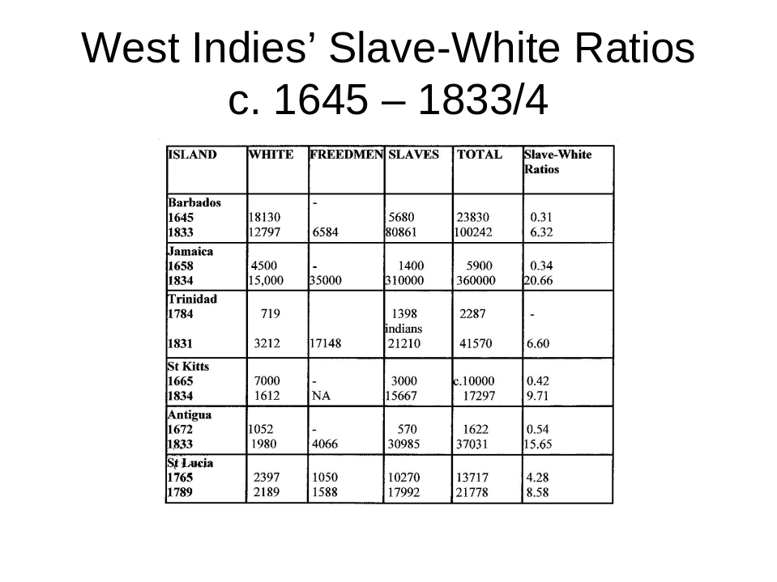

The original rise of the Planter Class was first to be observed in 17th century Barbados; but for obvious reasons the careers of these pioneers tend to be the least well documented. They were not (as Dunn 2000 remarks, mindful of the apparent compulsive record-keeping tendencies of contemporaneous Puritan settlements in North America) a people given to sustained systematic accounting for their daily or even weekly/monthly activities. Yet such evidence as exists implies they were content to inhabit quite modest wooden dwellings (increasingly better geared, over time, to the un-predictabilities of the elements); so long as they could live – and entertain – at a level which can only (judging from contemporary reports) have been gastronomically spectacular for the time. (Dunn 2000, Watts 1987). Yet for all this seemingly self-destructive life style, it was the evolving planter class of Barbados which was destined, in the long run, to be the one most committed to setting down family roots in the Caribbean - and hence themselves becoming increasingly ‘Creole’ in outlook (Watts: 333; Walvin2000: 46) Elsewhere - notably in ever-restive Jamaica – the temptation to quit the region just as soon as their own sugar estates looked sufficiently well established, for the sake of an easier and perhaps a more politically active life as part of the West Indies planter lobby in London, was evidently hard to resist (Watts; Dunn).
By 1775, in Jamaica, 30% of sugar estates were reckoned to be the property of absentee landlords and, by 1784, most of the 120 leading sugar estate proprietors in St Kitts were accounted absentee (Watts 276; 337). Whether it was burdens of debt, ‘over-taxation’ from Britain, revulsion at the climate or simply the attractions of life back home with access to metropolitan debate and political leverage, the West Indies planter classes (again with the partial exception of Barbados) stood apart from their counterparts in the mainland colonies of North America precisely in not taking root or even beginning to see themselves as more West Indian than British (Watts; Dunn). Ironically indeed, it was the uncertainties of the American War of Independence which seems to have put paid to what remained of residential sugar plantation ownership in Jamaica. By 1804, only 3 out of a total of its 120 plantation proprietors were resident in the colony (Dunn: 345-6).
Absenteeism might initially have made sense to established planter proprietors confident of being able to draw on seemingly guaranteed ongoing profits from their initial investments. But over the longer term it spelt ruin – or at the very least too much neglect and hence decline - not merely for themselves but of course for the places and people they had left behind. Absentee landlords had to rely on a variety of agents/overseers/attorneys to run their estates for them. Obviously the expenses of such cut into overall profits. More importantly the mere reliance on such intermediaries, situated at such a distance, could only have added to the chances of maladministration if not outright skulduggery. But this was not the worst of it.
Planter absenteeism per se was disastrous for the British West Indies per se, to the extent that it put at least a temporary blight on prospects for further agricultural innovation – precisely at the time when Britain was undergoing its own processes of agricultural revolution. Absentee landlords were in no position to innovate – or even to appreciate the need for further innovation (following the break-through achievements of the seventeenth century); any much more than were their paid, stand-in substitutes. All this at a time when, by the turn of the eighteenth into the nineteenth century, not merely were rival centres of sugar cane production coming on stream, but entirely different modes of sugar production were being sponsored within Europe as well.
The one set of people who might, conceivably, have been best placed to advise on ways forward for agricultural improvement on the estates were of course those least likely to have been consulted save, maybe, on an ad hoc basis by individual planters or managers. A striking characteristic of the slave communities evolving in the West Indies over this period was not merely their makeshift quality – forever consisting of mainly ‘first generation immigrants’ – but (to a latter day audience) the fact that this increasing majority of each island’s inhabitants were by definition excluded from any say, not merely in how it was run but in how their own work was organised and their tasks set.(Box 1). Indeed, in the opinion of at least one modern commentator, the condition – and conditioning – of plantation slaves was equivalent to that of mental patients assigned to a twentieth century asylum institution (Box 2).

Box 1
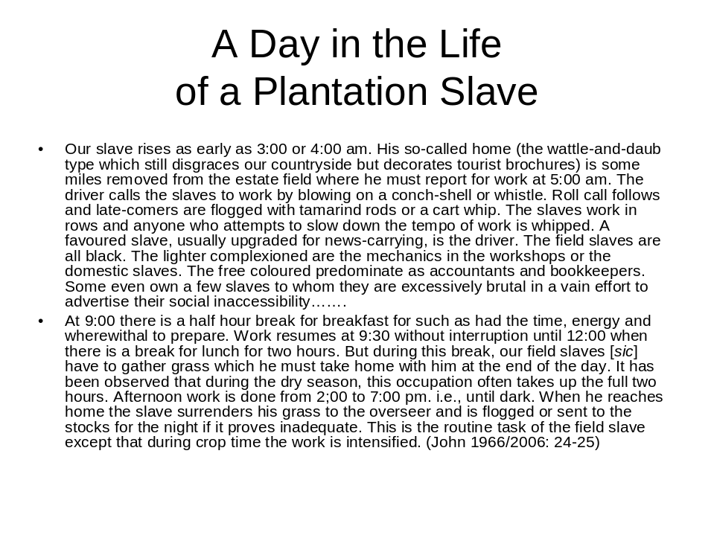
Box 2

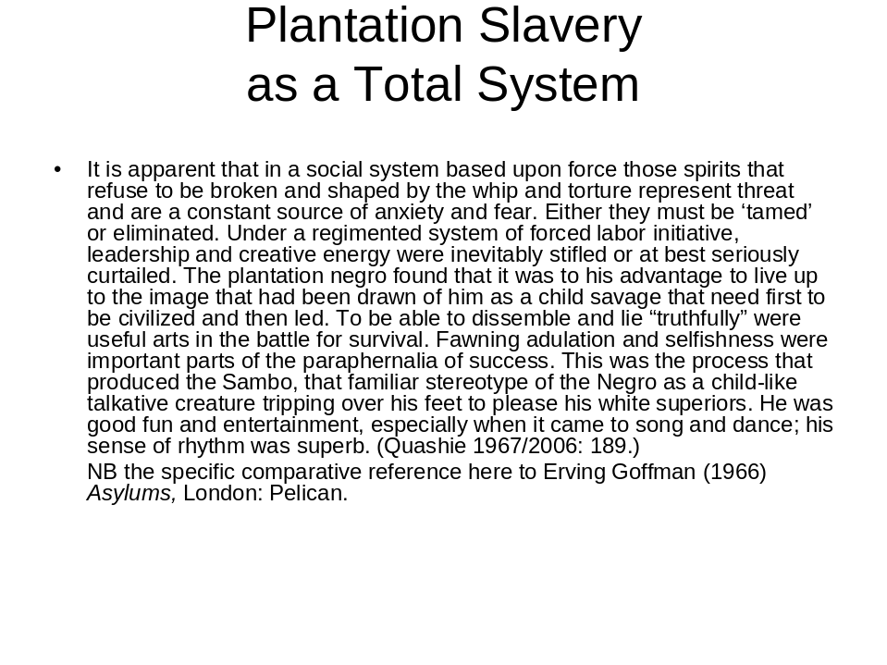

Even so, as at least Walvin contends, the everyday lives of slaves once resident in the Caribbean may not have been all that different from those of peasants in much of the then countryside of Europe (Walvin 2000: 47 et al.).

The enormities of the slave trade and of Britain’s commanding contribution to it have been extensively documented, not least by historians highly specialised in particular aspects of this subject. The tribal origins of particular groups of slaves, their reputed characteristics (not least their capacities for rebellion), the manner of their acquisition, the incidence and analysis of slave rebellions both at sea (en route) and, even more desperately (and for the most part hopelessly), on land in the Caribbean: these and more have all been the subjects of extensive and intensive investigation. For academics researching across this huge field, these may well have comprised the sorts of themes best capable of attracting funding attention as well as dedicated students. But their interests and findings have tended not to spill over into what should have been the overlapping concerns of other researchers into related other aspects of imperial history (cf. Walvin 2000: 8). Witness the ‘invisibility’ of the onetime ordinary lives of ordinary slaves to the nowadays student of societal and social policy development in the British Caribbean..

Yet there are some clues. Some 70% of the 10 million-plus slaves altogether transported from Africa between 1650 and 1807 were destined to work in “slave-grown sugar” which, by the early eighteenth century, “had made that leap, so common to a host of tropical staples, from [British] luxury to necessity” (Walvin: 22). But this scarcely meant they were all destined to be sugar cane fieldworkers alike. The complexities of sugar cane production and its industrial processing, quite apart from the need for at least minimal town support services for planters and their personnel, meant that African skills – and training potential – were in constant demand. Hence the evolving scope for enterprising slaves to be acquiring specialist skills - with a chance to be putting money together on their own accounts. Statutory holidays (principally a boon of the Christian Calendar – since planters themselves were bound to observe them) could be a way of simply letting rip, free from the cramping conventions of everyday life; whereas Statutory ‘Free Days’ could be way of earning private money (eg. Walvin: 48); as could the possibility of being rented out for hire to others by a hard-up planter; or that of being allowed to rent oneself out for hire, subject to a contract with one’s owner setting out the percentage of payments earned which was to be reimbursed to him (eg. Edwards 1819; Cateau 2002: 101-2 ).

In short, this may have been a murky world yet not one devoid of opportunity for at least some of the more energetic and perhaps the more desperately-driven people. The Equanios and Sanchos of this world (see Walvin 2000: Chs. 9 & 10 respectively) might have been spectacularly successful as much-travelled onetime slaves ending up famously literate and relatively prosperous in London; but they were not alone or even that unusual in having been able to carve out at least some sort of an independent future for themselves – starting from the purchase of their own freedoms (eg Walvin 2000: Ch 1).
Furthermore, for all that most slaves had not, as a rule, been transported and procured in family or tribal groups (the prime object - from the point of view of slave ship owners and captains, let alone eventual plantation managers - being to minimise the risks of slaves ganging-up together) and even though, aside from Barbados, most of the West Indies plantations in the age of the Slave Trade proved conspicuously unsuccessful at contriving a natural increase in their own slave populations sufficient to obviate the need for annual (and increasingly expensive) imports of fresh slaves, there were distinctive, regular, seasonal patterns to slave family and community life throughout the British West Indies by the late-eighteenth century. It was allegedly by this time that:
slaves in the British Caribbean appreciated that they had certain rights and access to free time. Though this might, in retrospect, seem a marginal benefit, on the very edges of a hostile and oppressive system, the slaves themselves sought to maintain, to preserve and when possible to advance those rights…..Word travelled fast and effectively from one slave quarter to another. Rights bestowed in one place were envied, sought or copied in another…..Masters who failed to conform to local customs were likely to find slaves taking matters into their own hands. Slaves simply failed to turn up for work on those days they deemed to be their own….(Walvin 2000:49)

This might well have been the beginnings of something big. After all, the plantation system had perforce functioned from the start – however minimally and grudgingly - as the main source of social provision for the majority of island inhabitants. (Box 3).

Box 3
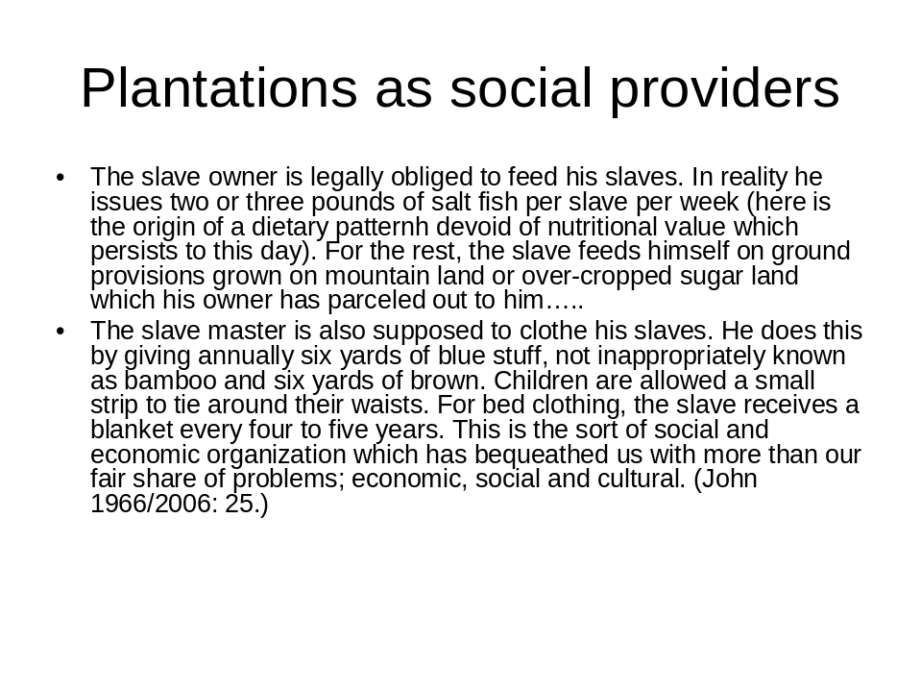

Yet it was a system creaking on too many other fronts already. The very idea of sustaining dedicated but increasingly antiquated modes of sugar production, geared exclusively to British requirements, was coming to look increasingly anachronistic back in Britain; especially now that more competitive suppliers were coming on stream. So it was that, with Britain’s international interests shifting away from the fixities of Mercantilism to the opportunisms of Free Trade, it was not merely humanitarian campaigners who were coming round to the idea of its not being in Britain’s long term interest to carry on with the anything-but-free slave trade it had hitherto made its own nor even, eventually, to carry on with the employment of such slaves as were still in situ for the production of its own exclusive supplies of sugar.

In the meantime, furthermore, fresh sorts of intermediate people had been accumulating; thanks as much to the opportunistic ingenuity of individual slaves with regard to earning and purchasing their own freedoms (or simply in staying escaped), as to planter susceptibilities (and/or ruthlessness) with regard to the availability of African women. Bryan Edwards, writing in the 1800s on The History, Civil and Commercial, of the British West Indies was at pains to quote a leading authority of the time (Don Antonio de Ulloa) on the panoply of terms applicable to the resultant variety of ‘persons of colour’ (ie. mixed blood) from mulatto (the offspring of a black woman by a white man) right down to the ‘practically white’ status of quinterone (the offspring of – usually - a white man and a quarterone woman; the latter being already four generations removed from pure negro stock ) with numerous complicated side- and sub-categories in between - all of which could significantly affect an individual or family’s civil and political rights, let alone their chances of a ‘fair trial’ (if indeed any sort of a trial) in the criminal courts (Edwards 1819:.18-23 et al.).
In practice, however, a coloured person’s chances of social and occupational mobility seemed to depend on the proportion of ‘pure whites’ actually resident in their vicinity.

In a community like Barbados, where there was a substantial white resident population, men of colour were subject to unequal competition with white colonists for superior employment. [Whereas] Where the European population was insignificant people of colour enjoyed ready access to the trades and secured leading places in medicine as well as merchandising. Caste distinctions were most rigid in colonies possessing the lowest ratio of whites to non-whites, and were most relaxed in islands where Europeans were few. Colour prejudice was most intense in Barbados where the lineage of every free person underwent microscopic scrutiny to ascertain whether he bore the slightest trace of African ancestry (Green 1976: 17.

Nevertheless, whilst marriage between whites and non-whites continued to be anathema to correct European opinion, informal liaison (between white men andcoloured women) continued commonplace. Indeed:

The white somatic preference which was inculcated in the status mentality of West Indians induced coloured women to favour concubinage with white men above marriage to men of mixed origins. ….concubinage conferred valuable economic advantages for women of colour. The concubine of a planter or town merchant enjoyed relatively comfortable living in a great house of town residence. She consumed better food, enjoyed more fashionable dress; not infrequently, she was awarded the services of slaves whom she could hire out as craftsmen, washerwomen , or peddlers. On the death of her keeper, a concubine and her children would be likely to inherit some, possibly all, of a deceased European’s property, including his slaves. The children of a concubine would be of lighter complexion than she, and in a society which placed a premium upon European somatic properties this would entitle her offspring to greater social and economic opportunities (Green 1976:20)..

Over time, socio-economic realities were thus to be geared more and more to shades of colour than to the simple absolutes of black versus white; especially once planter absenteeism had set in - for all that it was to take so very much longer for the institutions and practices of colonial government to catch up with and accommodate this truth. - The much-vaunted socio-economic malaise of the British West Indies after the abolition of slavery was arguably as much a product of the denial of aspiration to its indigenous would-be elites, as to the alleged absence of aspiration to be found amongst those freed from commonplace compulsory labour in the plantations.

DECLINE TIME: c. 1800-1950

The ending of slavery

Eric Williams’ contention (Capitalism and Slavery 1944) - that the ending, respectively, of the British slave trade (1807), of slavery itself in the British West Indies (1833-38) and of sugar trade preferences (1846) were all intimately associated with the ramifications of industrial revolution in Britain and thence with the espousal of free trade as the hallmark of empire - is difficult to resist, at least at this level of generality. This is not to question the sincerity or resourcefulness of successive, humanitarian, anti-slave trade and anti-slavery campaigners; simply to acknowledge that the timings of their efforts happened to be apposite for Britain in other respects. The abolition of the slave trade came at the height of the conflict with Napoleonic France- and was expected not least (given Britain’s capacities for monitoring sea-going activity in this respect) to hamper ongoing French prospects in Martinique and Guadeloupe. Whereas the abolition of slavery per se was associated with the diffusion of liberal ideas within Britain itself,: not merely about the liberty of the individual (of course) but, significantly, about ensuring that there was going to be an untrammelled, flexible supply of ‘freely contracting’ wage labour available for expanding industrial concerns to draw on, as and when required.

Once the abolition of slavery per se had emerged as a real political possibility in Britain (fired up by massive petition campaigns, together with massively organised worker boycotts of ‘slave sugar’, as in early nineteenth century Manchester - eg Drescher 1987: 200-6), the writing was surely on the wall for the old class of West Indies sugar planters, for all the time they were to take thereafter to fade away. Even so, it may well have been the violence and destructiveness of the Jamaican slave rebellion of 1831 which precipitated the final drive to action (Green 1976:112). Be this as it may, the fact that the legislation of 1833 emancipating slaves throughout the Empire was passed by the Liberal Reform Parliament of 1832 was no coincidence. ‘Freedom of labour’, in conjunction with freedom of trade, was to be the self-serving orthodoxy of Britain’s newly enfranchised business classes.

By the turn of the eighteenth into the nineteenth century the distant sugar islands of the West Indies were looking more and more anachronistic and marginal to British interests, not just on account of the slavery issue. Economically they seemed a declining asset – all the more so once the lure of free trade held out the possibility of access to burgeoning new areas (and modes) of sugar production both across the tropical world (Cuba, India, the East Indies…) and within Europe itself. Even so, perceptions of the scale of their decline before 1800 might, ironically, have been exaggerated by the sheer volume of London-based planter complaints to Westminster over the period (eg. Temperley 1987: 241). Nevertheless, the very notion of a slave-based, preferentially-traded sugar-production-and-supply system was crucially at odds with emergent liberal doctrines with regard both to free trade and ‘free labour’. The passage of the Sugar Duties Act of 1846 (whereby all sugar, from both Empire and non-Empire sources, was to be allowed into the British market on an equal basis) completed the process of disengagement first embarked on in 1807 with the abolition of the slave trade – and by the same token dealt a further long term blow to what remained of the archetypical West Indies’ sugar plantation system. (eg. Williams 1944: )

The British West Indies in the wake of emancipation:
the so-called mighty experiment
There was little evidence of any, detailed, thought-through planning for this future of the British West Indies. Rather, the potentially great, grand questions of how best to manage an unprecedented total shift from a slave labour into a wage labour economy were left essentially unasked - thanks, not least, to the obduracy of planters and their agents at the very idea of the governance of ‘their’ islands being subject in any way to interests other than their own.

The onetime hopes of sanguine slave trade abolitionists - that the mere prospect of a sometime end to slavery would both encourage slaves to be patient and prompt planters to take better care of those still in their possession – had already proved illusory.

“Contrary to abolitionist expectations (that abolition of the slave trade would lead to improvements in slavery)…..there were periodic rumblings of slave unrest. Worst still, the major slave revolts of the period (Barbados in 1816, Demerara [British Guina] in 1823 and, most violent of all, Jamaica in 1831-32) brought home the starker realities of slavery…..Slave discontent, upheavals, plantocratic punishments and retribution on an almost medieval scale deeply shocked British observers. To compound the growing British sense of outrage, many of the slaves involved were Christian.” (Walvin 2000b: 148)

After which, the hopes of emancipationists that slaves, once freed, were going to prove amenable to reaching ‘reasonable agreement’ with their former owners were likewise dashed. .

[The planter] suffers, not so much from the amount of expenses incurred by the wages, high as they are, as from the neglect and waste, and the damage which takes place upon the estate, which you cannot protect yourself against, and which you hardly dare attempt, in many instances, to find fault with…..The greatest loss arises from the deterioration in the quality of the sugar. A man is paid to skim a copper, and to attend to the work; he does not attend to the work, and you cannot compel him….[This] arises directly from the want of labor, which enables the labourer to do as he pleases, and you cannot find fault with him, because if you do he leaves your service, and you would rather have him to do his work badly than not have him at all. (Evidence to the Stanley Commission of 1842, quoted from Lai 1993: 6-7).

To be sure, there had been provision for a period of compulsory ‘apprenticeship’, obliging emancipated slaves to stay with their plantation ‘employers’ for a period of six (originally twelve) years after emancipation; in order to give time for ex-slaves to be ‘civilized’ into the norms of wage labour (before they had a chance to desert the plantations en masse), as well as to give planters time to adjust to new ways of management. But this entire scheme had to be cut short in 1838, owing to widespread ex-slave allegations that it amounted, in effect, to a prolongation of their slavery. “Full free” was the demand.
In no regard did apprenticeship fulfil the strategic expectations of its authors. The spirit of reconciliation and compromise upon which the success of apprenticeship depended was not forthcoming, and in retrospect it appears naïve that anyone should have expected it to. ….The same setting, the same tasks, the same planters persisted from slavery to apprenticeship with no break in continuity to allow old grudges to subside or new habits to develop. (Green: 160-161)
Even so, once the particular issue of apprenticeship had been dealt with, the bulk of anti-slavery campaigners in Britain seemed to have assumed their job was finished and done. There was to be no significant third generation of humanitarian campaigners dedicated thereafter to the defence and promotion of the wellbeing of former slaves and their descendants. However much wholesale slave emancipation had amounted to a leap into the unknown for all concerned (comparable to that of the slave-based sugar revolution in the first place), the predicaments faced by ex-slaves (not to mention their ex-owners) lacked the rallying potential to galvanize an imperial British public whose global attentions were already focussed elsewhere.

Admittedly there were two follow-up Commissions of Enquiry, appointed respectively in 1842 (chaired by Lord Stanley, to report on post-slavery conditions in the plantations) and in 1848 (under Lord Bentinck, to investigate the effects of the Sugar Duties Act on the region). But both of these, by definition, were there to suggest ways of responding to problems after their event, rather than to map out strategies for forestalling such from the start. In place of mercantilism the doctrines of the day were now laissez faire: rather a large shift in imperial style for the ‘freed-up’ British West Indies to have to cope with at short notice.

All the same, there was no single standard pattern to the fall-out from 1833-38 or for that matter from 1846 in the British West Indies. Outcomes were everywhere uncertain and never anywhere quite the same. Over and above the interplay of key personalities in particular places, so much seemed to depend on situations and circumstances highly specific to one island – or even to a particular location within it; be these matters of topography, land ownership, land use, population make-up and its distribution, proximity to towns for potential urban relocation or to ports for migration elsewhere (especially to the ‘new’ centres of Trinidad and British Guiana)….Every case was a local case. Yet, with hindsight, there are alternative patterns to discern.

Migration within the Caribbean was (and long remained) the first, most obvious and flexible resort for those otherwise trapped in unfavourable circumstances. Notwithstanding the efforts of planters to legislate against such a haemorrhaging of their labour resources, more than 27,000 onetime slaves were estimated to have transported themselves from the likes of Barbados and the Leewards to the new & expanding prospects of Trinidad and British Guiana (on the South American mainland) before 1849. (Green: 263-4) Whereas for those who remained (or found themselves unable to leave):

Wage rates varied in relation to the availability of labour……Apart from seasonal fluctuations, the rates of monetary payments were determined by the workers’ places of domicile, the jobs they performed, and the extent of food and other allowances (including, in some colonies, houses and grounds) they received. In general terms, however, the price of labour was lowest and its efficiency greatest in the high density colonies where competition for pay and allowances was most keen. In Barbados, Antigua, and St Kitts, first-class labourers commonly worked by the day, a period of nine hours. During the early forties they earned about a shilling a day, sometimes less, plus allowances of rum, salt meat, and provisions.
Attempts by Jamaica planters to establish equally low wage rates were frustrated by Baptist missionaries and others who successfully induced workers to hold out for 1s 6d a day…..In Trinidad and British Guiana where labour shortages were especially grave, freedmen earned 1s 8d to 2s 1d a task, and able bodied workmen could perform two, sometimes three, tasks a day. (Green:196-7)

In other words, where an island’s development had effectively been one of plantation mono-culture – as in the small, densely populated and densely cultivated islands of Barbados, St Kitts and Antigua - there was not much scope other than for former slaves to stay with plantation work (for whatever wages they could get), since there was virtually no spare land available for settlement outside of the plantations. Whereas in small islands such as Nevis, where the sugar plantation culture had never attained complete ascendancy, struggling planters could end up willing to enter into share-cropping arrangements with former slaves (and/or to lease out or even sell off parcels of land to them for free-lance cultivation) as being their own best means of staying afloat (eg Byron 2007: 247-8).

By contrast again, Jamaica was not merely the largest island but also the most plentiful in mountainous, difficult to access and difficult to cultivate terrain - such as had always attracted runaway as well as freed slaves and which now offered at least a minimalist peasant/squatter/free village prospect for former slaves in search of an independent life. Then again Trinidad - the second-largest and latest acquired of the British islands, whose previous Spanish proprietors had had to legislate as recently as 1783 to attract suitable ‘neighbouring Europeans’ (who were mostly French) into this colony to try to make good its dearth of population (see above) - was still possessed of sufficient un-appropriated land to render the retention of former slave workers on its plantations problematic. Which, taken together, explains why it was the owners of plantations in Jamaica and especially Trinidad (in addition to those of the equally late-acquired and ‘un-allocated land-rich’ British Guiana on the South American mainland) who ended up petitioning for permission to import supplies of indentured workers from elsewhere to make good their otherwise catastrophic shortfalls in plantation labour (eg. Lai 1993 ).

Table 2.5: Migrants introduced into the British Caribbean,
Mainly under Indenture: 1834-1918

 | India  (1838-1918) | Madeira  (1835-81) | China  (1853-84) | Africa  (1834-67) | Europe  (1834-45) | Other  (1835-67) | Total  Migrants
B. Guiana | 238,909 | 32,216 | 13,533 | 14,060 | 381 | 1,868 | 300,967
Trinidad | 143,939 | 937 | 2,645 | 8,854 | - | 1,333 | 157,668
Jamaica | 36,412 | 379 | 1,152 | 11,391 | 4,087 | 519 | 53,940
Grenada | 3,200 | 601 | - | 2,406 | - | - | 6,207
St Vincent | 2,472 | 2,102 | - | 1,036 | - | - | 5,610
St Lucia | 4,354 | - | - | 730 | 114 | - | 5,198
St Kitts | 337 | 2,085 | - | 455 | - | - | 2,877
Antigua | - | 2,527 | 100* | - | - | - | 2,627
B. Honduras | - | - | 474 | - | - | 178 | 652
Dominica | - | 164 | - | 400 | - | - | 564
Total | 429,623 | 40,971 | 17,904 | 39,332 | 4,582 | 3,898 | 536,310
* One hundred Chinese were landed on Antigua in 1863 from a French vessel stranded off the island of Barbuda.
Source: Quoted from Walton Look Lai 1993: Appendix 1, Table 5, p. 276

Unlike the earlier ventures into indentured labour for the Caribbean of the seventeenth century (see above), these latest arrangements were subject to detailed British government direction, regulation and control (Lai 1993:51) – made possible, this time round, as a result of Britain’s being by this time in charge of an expanding empire with access to plentiful supplies of poor people willing or desperate enough to sign up for postings which, for most of them (see Table 2.5), meant travelling half-way around the world. Nevertheless it was assumed – indeed specified in their terms of contract - that this was to be a temporary migration and that all those concerned would duly be returning home (for free – or at least at a special cheap price) on completion of their periods of indenture. Which, in retrospect, turned out to have been a naive assumption.

Plantation labour still not being to most people’s taste, enough of the minority of Chinese imported labourers proved no less adept than numbers of their South Indian counterparts, for instance, at disappearing from plantations well before their indenture times were up, in order to re-emerge most typically as traders in what were, for them, more congenial local urban settings (Lai: eg. pp.103, 105). Such a continuing Indo-Chinese presence was to be a factor of long term significance for Trinidad especially – the island which had already, by the time of its British acquisition, become home to the most ethnically mixed population of anywhere in the Caribbean.

In sum:

Emancipation modified the class structure of the West Indian colonies without destroying its hierarchical character or the criteria upon which that hierarchy was founded. Although occupation, wealth, and education were determinants of class status, race remained the fundamental factor. The white bias infused in the status mentality of West Indians during slavery has survived to our own times, and it may be presumed that the intensity of that bias was especially strong in the years immediately following emancipation. (Green:295)

Issues of Governance

Within the newly emancipated (and in some cases still being freshly populated) West Indies, the matter of the franchise was an especially sensitive topic. Island Governors had typically been answerable to elected assemblies whose narrow, property-based franchises had served as the cornerstones of white oligarchic power. The franchise had always been restricted to free men and, until the last years of slavery, had generally been reserved to Europeans. Property qualifications for the franchise during slavery were low – normally around £10 annual freehold value. But emancipation threatened, over time, to inundate island electorates with numerous qualified black and coloured voters. To preclude this, assemblymen throughout the British Caribbean set about revising their franchise laws with view to raising the property qualifications for new voters – whilst at the same time safeguarding the rights of ‘old’ [white] voters not in a position to meet the new qualifications…..

The [British] Government’s so-called high-minded (ie initially negative) response to these manoeuvres was bitterly contested by the planter classes - and nowhere with more success than in Barbados:

From 1835 to 1841 the Barbados legislature, supported by successive governors, tried to tighten the island’s franchise law….by the end of 1841, Lord Stanley, engulfed in a climate of conciliation and persuaded by the persistent remonstrances of the colonial legislature……approved a complicated and restrictive law which had the effect of preserving a uniformly white Barbados Assembly throughout the mid-century. As late as 1857 the total number of registered voters in Barbados (population exceeding 135,000) was only 1,350.
Green:176-7)

In explanation of which:
The unique success of the Barbados planters may be attributed to their large and disciplined pool of wage labourers. This asset vastly offset the cost of annual replanting, the purchase of imported fertilizer [both features of the soil-impoverished Barbados setting], and the comparatively high unit costs of small sugar properties. It permitted the planters to exercise their skills, to expand their cultivation, and to preserve the quality of their product. Most Barbados planters earned some profit in years of lowest prices. As a uniquely solvent proprietary class they were able to attract investment capital for plantation maintenance and renovation. The colony’s estates did not pass to metropolitan capitalists [as happened elsewhere in the British West Indies] and throughout the century the typical Barbados proprietor remained the head of a family, not the head of a merchant company. (Green:259)

In short, it was the very continuity of planter and plantation supremacy in Barbados which obviated the need for this particular oligarchy ever to have to petition Britain for a shift to Crown Colony status (ie for the abolition of its Houses of Assembly) in order to avoid being swamped by a superfluity of coloured property holders entitled to vote. Whereas transfer to Crown Colony status was precisely the ‘needs-be’ choice of the Jamaican Assembly in 1866 (in whose 1863 elections just 1,457 votes had been cast, out of a population numbering above 440,000 -Green:176-7), as being its best chance of staving off take-over by an agglomeration of increasingly propertied, professional, coloured, middle classes. This drastic move came in the wake of the infamously handled Morant Bay Rebellion of 1865 (itself sparked off by Queen Victoria’s refusal - on the advice of Jamaica’s then Governor Eyre - to release vacant Crown lands for peasant cultivation) and was a first indication of what was subsequently to be a widespread phenomenon: the no less needs-be identification downwards of frustrated West Indies middle classes with the locally poor and un-possessed. Meanwhile, the Morant Bay Rebellion may have been particular to Jamaica, but the resort to Crown Colony status was an initiative to be copied, for more or less the same reasons, by every other British possession in the region (save of course Barbados) which was not already a Crown Colony.

It was hardly a long term solution to problems either of land management or social regeneration within islands which were already showing themselves more and more vulnerable to fluctuations in the international markets for their produce. Socio-political unrest was thus to remain a feature of life in the British West Indies – to which there was never – and perhaps could never be - a ‘sufficient’ British colonial response.

The ‘Norman’ Commission of Enquiry (1896-97) into the economic malaise of the British West Indies conducted its investigations in accordance with the finest traditions of Victorian Blue Book investigation. Its members painstakingly gathered a wealth of first hand evidence, not merely from planters and their ilk but via general public hearings convened throughout the region (eg. Richardson 2007: 21-23); as a result of which they offered careful recommendations for the settlement of selected British West Indian labourers “on small plots of land as peasant proprietors”; together with the improvement of minor agricultural industries, cultivation systems and the hoped for establishment of an international trade in fresh tropical fruit (especially to the US - this last to be backed by the “grant of a loan from the Imperial Exchequer for the establishment of Central Factories in Barbados” – Richardson: 22). But they held back from recommending anything so drastic as inter-island federation (given the insularity of the peoples involved as well as their geographic diversity). Nor could they bring themselves to support the case for protective tariff reform (versus beet sugar imports into Britain from the European continent) so dear to the heart of the then Secretary of State for the Colonies, Joseph Chamberlain, as part of his conviction that the colonies should be properly utilized and developed as a grand estate in Britain’s own interest . (Richardson: 23). Least of all were the Commission’s distinguished members minded to challenge the fundamentals of land resource and opportunity allocation across these onetime-plantation places.

By this showing, emancipation seemed not to have resulted in equal rights so much as in an equality of entitlement to carry on as near as possible as before – albeit under a notionally different set of ground rules. The West Indies’ huge majorities of the un-possessed and marginally possessed were of course free, in principle, to withdraw their labour (and/or, in some alleged ‘ideal’ situations, to decide for themselves just how many hours and times of the day or week it was necessary to work in order to sustain the lifestyle of one’s choice). But there were telling snags so far as most of the emancipated were concerned: they could never be sure which generation of rules was going to be adhered to in practice (witness the Morant Bay atrocities referred to above); the only alternative to plantation labour could well be mass homelessness if not outright starvation; and there was not too much for even the most determined of the upwardly mobile to aspire to legitimately.
The municipal ratepayer riots (over metered water rates) in Port of Spain, Trinidad, 1903, demonstrated the consequences, yet again, of leaving a frustrated mix of professional and urban trading classes with seemingly no choice other than to identify downwards with the labouring poor and unemployed. In this case it resulted in the famous burning-down-by-the-mob of the Red House of government on March 23 1903 as a precondition, in effect, for the eventual restoration of at least a ratepayer-elected city council to Port of Spain (http://countrystudies.us/caribbean-islands/14.htm).
It was not until the 1940s, after the devastatingly widespread riots of the 1930s (see below) and once the hostilities of the Second World War were mainly over, that full adult suffrage, linked to responsible and answerable forms of government, came to be granted – piecemeal - to the British West Indies (Box 4)
Box 4
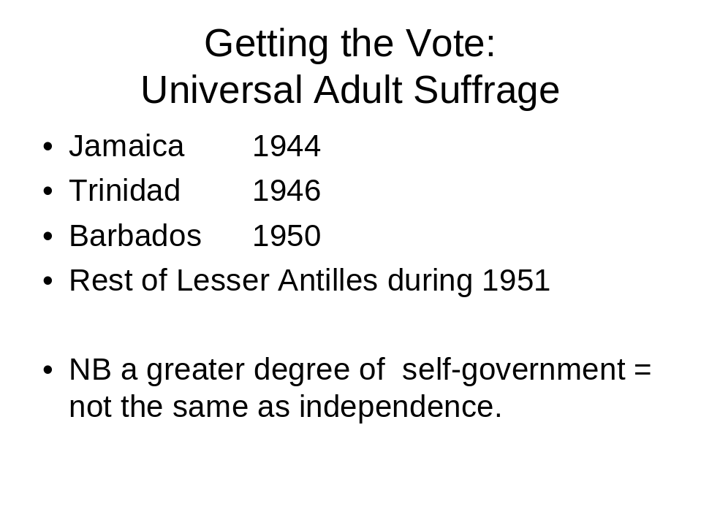

Development and welfare

If the original plantation arrangements for social support had been grudging and rudimentary (see above), those available to post-plantation generations of the unskilled and under-employed could be non-existent - save, ironically, in such tradition-bound and - in a sense - ‘land-locked’ locations as Barbados. It was here, for instance, that the ‘medieval, manorial’ style of worker support systems was reputed best to have survived as a means of keeping ordinary people more or less quietly if not contentedly in their place. Housing, health care (such as there was) and access to land for self-cultivation, so far as the vast majority of the population in Barbados was concerned, was still tied to employment on the plantation; just as were educational arrangements all about training for specific jobs in hand - rather than about enabling and encouraging individuals to get ahead on their own account.
Elsewhere in the West Indies and outside of the plantations, ratepayer-elected local councils were typically far too short of money to contemplate more than the most meagre of provisions for emergency health and poor relief. The provision of popular education had mostly been left to the various Christian Churches after emancipation – which, by the 1870s and the onset of mass compulsory education (following England’s own lead ) meant the ‘exposure’ of increasing proportions of children to increasingly ‘creolised’ versions of Christian teaching (Green 1976: Ch.11). Whereas, just as in the then Britain, secondary education tended to be the preserve of those whose parents could afford to pay for it. Which, given the school curricula espoused, signified in effect the spread of nineteenth century British public school values – the importance of sporting prowess included - across what might be termed the upper reaches of British West Indian society. Campbell (1996) in respect of Trinidad and Tobago and Seecharan (2006 ) with regard to the links between cricket and West Indies educational ambition in general, have much to say, between them, about what Thomas Babington Macaulay would have recognised, from an earlier age, with regard to another place, as the useful production of a class of well-disposed, intermediary potential functionaries “English in taste, in opinions, in morals and in intellect”. The only snag was that, unlike the case with British India with its vastnesses of subsidiary career opportunities (not least within the Indian Civil Service) , there was as yet nowhere obvious for the British West Indies’ potential high fliers to turn their talents.
It was not until the 1920s, with the rising influence of the Labour Party - coupled with that of the Fabian Society - within an economically troubled Britain, that there was even active encouragement for the spread of TUC-affiliated trades unionism in the West Indies. Which was also the time when Joseph Chamberlain’s notions of pursuing pro-active colonial development policies in the interests of Britain (see above) seemed at last to be taking root within the British establishment. The 1929 Colonial Development Act , passed by a Labour government allegedly on the basis of a Conservative election manifesto promise (Cassell 2003) was heralded as signifying, at last, a real change in Britain’s approach to its colonies (as opposed to its Dominions, of course). (Box 5)
Box 5
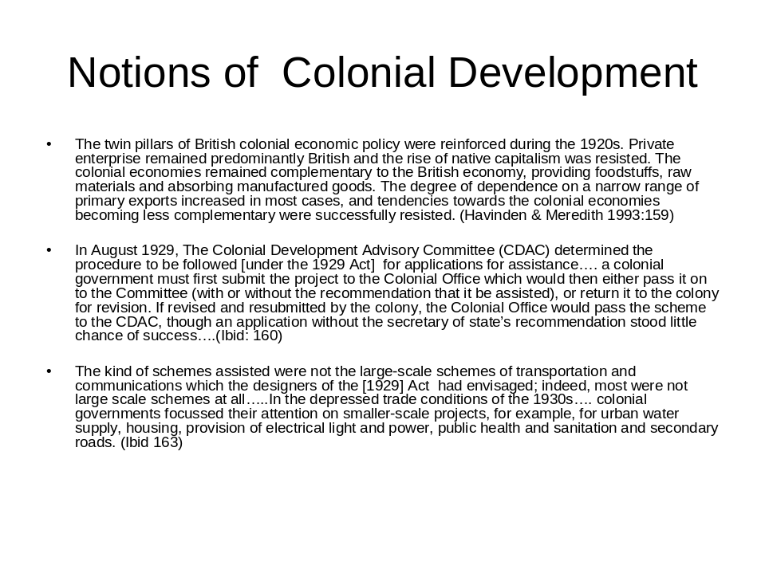
The 1929 Colonial Development Act was a first official attempt to formalize Chamberlain’s hitherto ad hoc approach to assistance in aid of colonial development. Colonial assistance was now to be given only after a systematic examination of all schemes and projects put forward by the respective colonial governments. The act introduced a greater degree of self-consciousness and systematization – and created machinery for the systematic examination of all projects. Abbott 1971: 70) But it also, by the same token, established the precedent – and thenceforth the expectation – of there being inordinate administrative delays involved in the approval process (let alone in the financing process) for projects which had first to be submitted by colonial administrations (in all their homespun variety) for examination by a range of decision making agencies operating in respect of the Caribbean as a whole, as well as back in London (eg Cassell 2003). Furthermore it brought home the truth to their governments, if not to the general run of people in the West Indies, that any development aid from Britain was going to be conditional on its being of measurable benefit to Britain (eg via enhanced employment opportunities back in Britain, coupled with an enhanced security of food supplies for Britain, right down to contracts which specified the minimum proportions of expenditure on necessary materiel which was going to have to be spent in Britain, on British goods) in order to qualify for any Aid at all (Cassell 2003).
This was scarcely revolutionary stuff. But the time for gradualist, consensual, would-be cumulative reformist solutions was probably already running out for Britain and its Caribbean colonies immersed in Depression. The outbreak of mass protests in St Kitts over the denial of pay increases to sugar workers (1935) was followed in the same year by riots in St Vincent over an increase in customs duties and a strike at the Castries coaling station in St Lucia. Which turned out to be a foretaste of worse to come.
In normally placid Barbados pent-up frustrations were released when the colonial authorities arrested and deported Clement Payne [in the summer of 1937], as a trade union organizer who had arrived in the island from Trinidad. Payne was a charismatic speaker who [had] told his growing audiences about the riots in neighbouring islands…….For two days thousands rioted and looted in Bridgetown and around the island before police shot dead fourteen and wounded forty-seven in a series of confrontations. Over 400 arrests were made and several people were jailed for sedition. (Ferguson 1998: 244).
After which a strike for better wages by oilfield workers in Trinidad turned into widespread violence thanks to a clumsy police & British naval response which resulted in fourteen of the rioters being shot dead and fifty-nine wounded. After which, again, came the last and greatest manifestation of pent-up social discontent, in Jamaica, in early 1938. It was in the wake of a series of strikes on sugar plantations that dockworkers and street cleaners in Kingston decided also to stop work; whereupon
The situation rapidly deteriorated when mobs attacked shops and trams, blocking streets with barricades. During a week of unrest, troops killed eight protesters and wounded 171, while over 700 Jamaicans were arrested and charged with public order offences. It was perhaps the worst outbreak of disorder to be experienced in the British Caribbean and one which was to have lasting effects. (Ferguson 245)
The Moyne Commission of Enquiry of 1938 was appointed, significantly, to enquire not merely into the socio-economic but by this time the socio-political malaise of British colonies in the West Indies. The Commission’s damning findings with regard to the extent and nature of their deprivation and underdevelopment (Box 6) were delivered in 1939 though not actually published (owing to ‘fortunes of war’) until 1945. Nevertheless, for all the Treasury’s innate suspicion (Box 7), they did result in the swift passage of a Colonial Development and Welfare Act in 1940 (emphasis added), which implied at least some shift in thinkiing.

The notion of colonial self-sufficiency had been a cornerstone of the British approach to Empire. Colonies, once established, were expected to be self-supporting; capable of contributing to the metropolitan British purse without being a drain on it. But it was scarcely a doctrine capable of responding to the situation and requirements of the British West Indies in the twentieth century.

Box 6
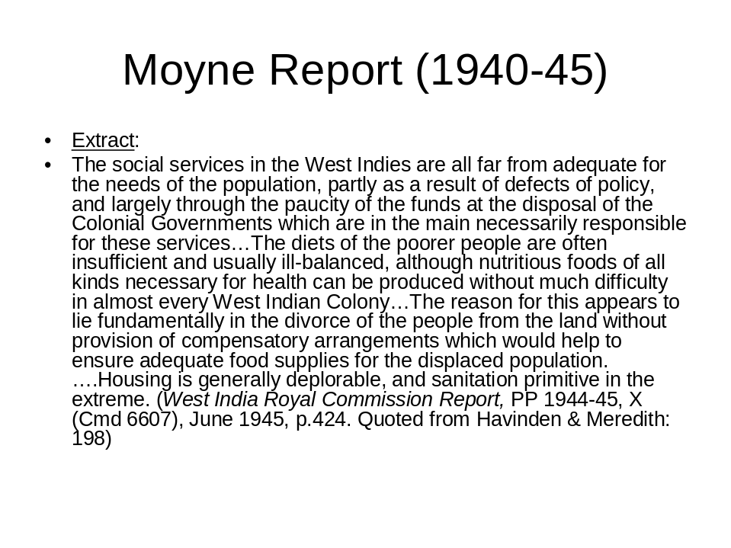
Box 7
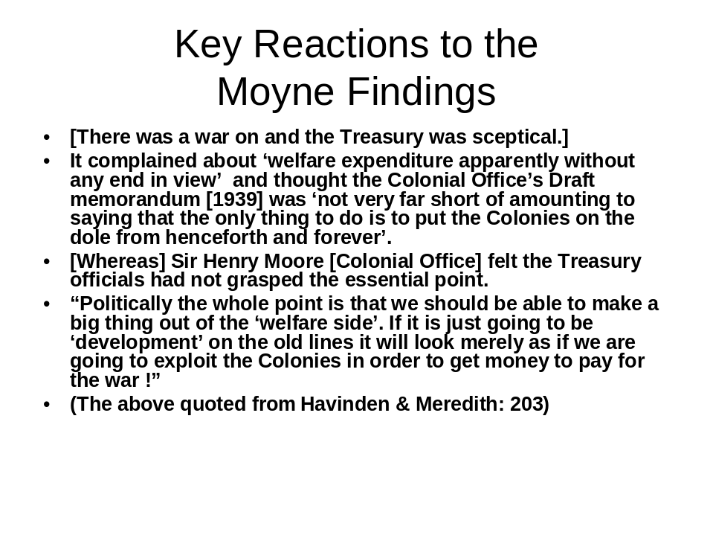

Even so, the Colonial Development and Welfare Act of 1940 allowed for the expenditure of up to £5 million per annum for ten years on approved development and welfare projects to be submitted by individual colonial governments. Expenditure under the Act was slow at first – given that schemes deemed not to have a direct bearing on the war effort were ranked unlikely candidates “for the expenditure of United Kingdom Funds in present circumstances” (Colonial Development and Welfare, Report on the Operation of the Act to 31 October 1942, pp. 1942-3, IX (Cmd 6422) 601, p.4.). However, by the end of 1946, its final year of application, the Act had allowed for a total expenditure of some £28,889,177, 15% of which had gone to agricultural & veterinary projects; 14.4% to communication and transport; 13.4% to education; 13.4% to ‘medical, health & sanitation’ and 22.3% to water supply & irrigation projects (Box 7). Furthermore, no less than 38% of the entire total had been directed to the West Indies; as against 34.5% to West Africa and 15.7% to East Africa (Havinden and Meredith 1993: 220-222).

Box 8
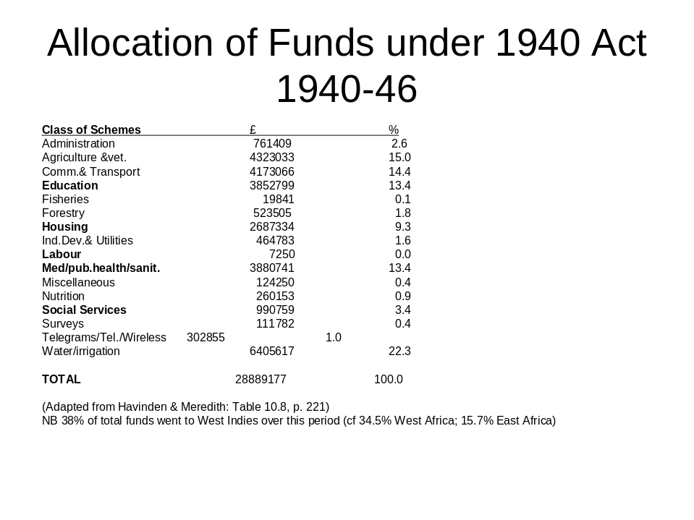

Notwithstanding this order of generosity, however, there was to be criticism of the Act’s operation and application within the West Indies on three grounds: procedural, practical and conceptual. In procedural terms, it was the inevitable (and perhaps intended) bureaucratic delays to be expected from the multi-layered, multi-agency, to-and-fro intricacies built-in to the meticulous applications process, which struggling colonial administrations could find it hard to cope with – if not pointless to waste time over. For those who did, and were successful, it was the gap between a project’s choice of objectives and the chances of these actually being delivered via the infrastructures available which accounted for the bulk of practical complaints over the workings of the Act (eg Cassell 2003; Simey 1946). Whereas for those in search of a longer term vision for the future, it was precisely the piecemeal, ‘down-to-earth’, project-by-project, take-it-as-it-comes concept of ‘Development’ which was the greatest cause for concern.

In his classic Welfare and Planning in the West Indies (1946), T.S.Simey castigated British officialdom not so much for its parsimony as for the short termism of its approach to Development and Welfare in the Caribbean. It made no sense, in his view, to be trying, vaguely, to tack on additional social services’ provision to governmental systems incapable of delivering it and to economies incapable of generating the finances to pay for it. In short, there could be no meaningful social and social policy development divorced from issues of economic development (Simey 1945: Ch IV especially). This was tough talk coming from a sociologist on wartime academic release to the Caribbean from his home City & University of Liverpool. But the analysis was well founded and its implications relentless. Without there being comprehensive investment in their economic development and thereby social reconstruction (ie. on a scale and of a nature never hitherto contemplated for anywhere in the Empire), the islands of the British West Indies scarcely looked like viable propositions. Furthermore:

The main objective in putting forward these ideas is to strengthen the apparatus of government so as to avoid a repetition of the mistakes which occurred a century ago, when it was obvious to many that measures should be adopted to rebuild West Indian society, although few realized that this could not be achieved through the administrative apparatus as it then existed. It must be realized that there is a grave danger of this situation repeating itself to-day. The administrative reforms of the first half of the twentieth century would probably make it possible to carry out the measures which the conditions of the 1840s demanded, but it is improbable, to say the least of it, that they are adequate to meet the needs of the 1940s. (Simey 1946: 249)

Nevertheless the 1940s was not the best time for British governments to be envisaging – let alone taking on – extensive schemes for colonial revitalization. It was the arrival of the Empire Windrush in Tilbury docks on June 22nd, 1948, which marked the start of an own style of individualistic West Indian response to the paucity of prospects in their islands: long haul migration to the Mother Country, of which they had been taught so much. But for all furore this raised it did not – unlike in the faintly comparable Irish case of a 100 years before- result in post war British governments investing conspicuously in West Indies Development in any serious attempt to encourage more West Indians into staying at home; certainly not on anything like the scale or with the penetration that Simey had recommended. The West Indies continued a conundrum of Britain’s own making for the British still to have to try to resolve.

‘ON YOUR OWN’ TIME: c. 1950s on

Issues over independence

The colonies of the Lesser Antilles - and even Jamaica in the Greater Antilles (tiny by comparison with Cuba and Hispaniola) – were considered at best doubtful prospects for independence after World War Two. They were too small (Box 9 as a reminder); their economies were too unbalanced (being mostly still geared to the production of a limited and chancy range of exports for Europe, rather than to domestic self-sufficiency); and their peoples were too impoverished, as well as too unschooled in the arts of governance. Much the same might of course have been remarked , say, of Singapore after 1945 (eg. Jones 1990), but the West Indies were further compromised by their geo-political location: being in the backyard of an all-powerful and agriculturally self-sufficient USA, rather than at the hub of the competing, cross-cutting trading/shipping lanes of southeast Asia.

Box 9
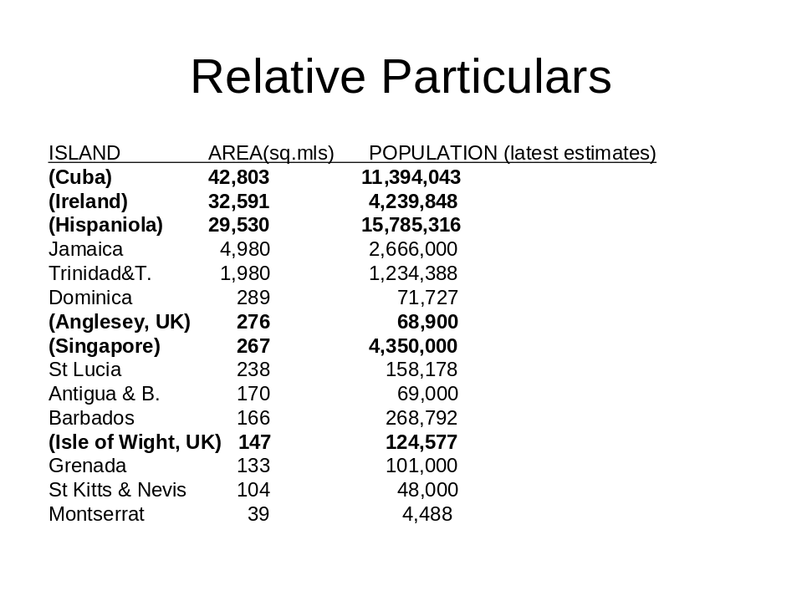

What could the future hold for the Caribbean’s small island mix of mainly British, but also French and Dutch, possessions ? None of these colonial powers – but perhaps Britain especially, given the huge extent of the country’s other ongoing commitments – was in a position to simply carry on as before. However the French and Dutch responses to the conundrum were distinctly different from Britain’s – in that both the French (in respect of Martinique and Guadeloupe) and the Dutch (in respect of Aruba, Bonaire, Curacao, St Maarten, Saba, St Eustarius) opted to incorporate these former colonies into the body politic of their respective states. Thus:

As subjects of the Kingdom of the Netherlands, the inhabitants of the Dutch Antilles are entitled to live and work in the Netherlands and [meanwhile] receive an estimated per capita US$500 each year in direct subsidies from The Hague.

France is also prepared to transfer huge resources to its Caribbean departments d’outre-mer, whose citizens enjoy entirely equal status to those in the metropolis. The extent of the French subsidy is concealed by complicated accounting procedures, but it has been estimated that annual per capita income would fall from over US$6,000 to a mere US$800 without the billions of francs sent from France….With first-world social services and consumer tastes, the inhabitants of Martinique and Guadeloupe are envied by poorer, independent islands which receive no such European largesse. (Ferguson1998: 323)

However much the actualities of life as a Dutch or French overseas citizen might have turned out differently from the formal equality of status accorded them, there was not much comparison between their treatment and that on offer to inhabitants of the British West Indies.

To be sure, the British Nationality Act of 1948 had ostensibly conferred British citizenship (rather in the spirit of Pax Romana ) upon all its remaining colonial subjects; but this was not, as it turned out, a gesture intended to encourage or facilitate their actually taking up residence in Britain. Rather, as the response to the first ‘naïve’ migration from the Caribbean to Britain bore out, the British people (whose average grasp of West Indian realities turned out to be near-zero) proved anything but disposed to look on the new arrivals as in any way ‘fellow citizens’ (eg. Francis 1998; Levy 2004). It was the strength & depth of their blanket hostility, indeed, which prompted the passage of the first, back-stepping, Commonwealth Immigrants Act of 1962, whose provisions distinguished, painstakingly, between incomers with a recognised qualification or an actual job to go to – as against those (typically West Indian, by contrast with the much better organised family networks of Indians and Pakistanis) who were simply coming in ‘on spec’ (eg Jones 1977).

In truth, there was never any question – nor indeed any precedent, save in the murky case of Ireland - of systematically incorporating the inhabitants of any onetime colony into the British body politic. The only options available to the onetime imperial possessions of this bedrock of nationalistic, individualistic, twentieth century liberal democracy, were either independence or continued dependence – on terms to be arranged by Britain. Britain per se was not to be enlarged. (Though, ironically, it was the reckless individualism of the first waves of West Indian immigrants which was to trigger the beginnings of Britain’s own tortuous transition towards becoming a so-called multi-racial society.) The one mollifying gesture intended, over time, to soften the starknesses of Empire break-up for all concerned was the creeping transformation of ‘The British Commonwealth’ (a club originally exclusive to the so-called (White) Dominions of the Empire) into a plain, self-consciously egalitarian and near all-inclusive ‘Commonwealth’ geared to functioning as best it may – however awkward the successive circumstances - as a soothing, smoothing “voluntary association of independent states that consult and cooperate in matters of common interest…” (McIntyre 2001:10).

Meanwhile, however, back in the Caribbean – still devoid of the massive scales of outside investment advocated by the likes of Simey as well as, implicitly, by the Moyne Commission before him – underlying local problems continued unresolved. The best, practicable solution from a Colonial Office point of view, was to see as many as possible of Britain’s West Indies possessions Federated under a new form of collective government possessed of sufficient bargaining clout to carry weight in the world of free trade as an independent collective operator. Something along these lines had indeed been a long standing British idea – except that the hitherto exercises in Federation had been purely matters of governmental convenience, whereby one governor could reasonably be expected to preside over the affairs of several neighbouring islands. Whereas Federation as a substitute for individual island independence, in conditions of democracy, was a proposition completely untried and unprepared-for. There was nothing in these islands’ highly competitive histories to have prepared them for any such ‘sink the differences’ venture. Even their respective education systems had all along been geared more to learning about Britain than about each other.

Hence it was that the West Indies Federation proved a non-starter virtually from the word go. Once Eric Williams, Prime Minister of Trinidad & Tobago, had famously declared (in the wake of Jamaica’s withdrawal) that “ One from ten leaves nought” (ie. that the Federation could not hope to function without its potential biggest player), the Federation idea was effectively dead Which left a vastly open question as to where all of the respective islands were supposed to go next. (Box 10)

Box 10
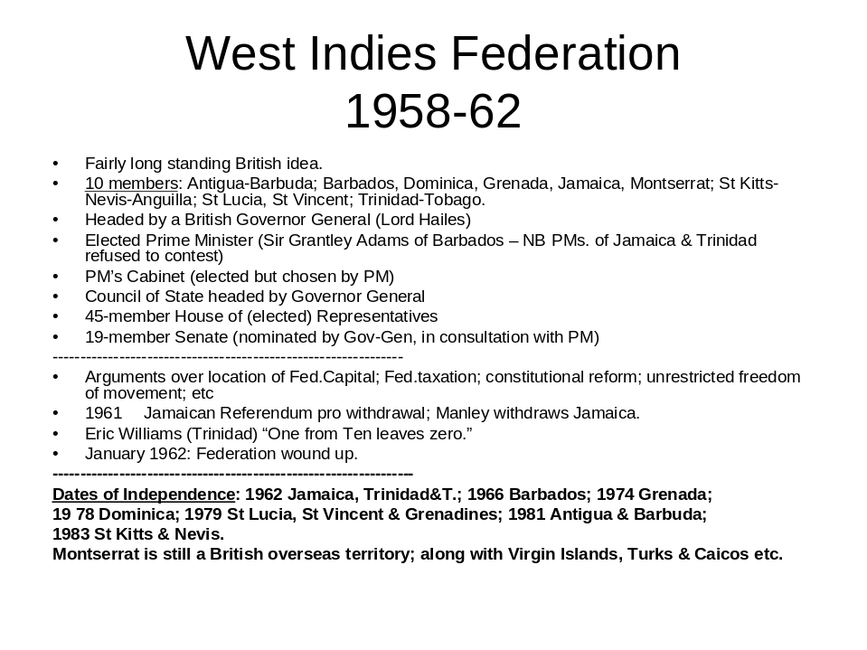

Formal independence was one thing, for those capable of contemplating it. But they were not all in the same state of readiness (or otherwise) for this, never having been run according to a standard format – or with independence ever formally in mind until, in effect, the last minute. Hence the scattering of dates for eventual Independence (Box 10 again), coupled with the telling fact that it was not until 1998 that Britain accorded the inhabitants of its remaining, tiniest, dependent territories (the Cayman Islands, Turks & Caicos, Montserrat, Anguilla, the British Virgin Islands) the revised designation of overseas territories – coupled with the grant of full citizenship at last to their inhabitants – entailing the right to settle in Britain whenever and if ever they should so wish (Ferguson: 324).

Issues of socioeconomic viability

As already observed, these colonies had been contrived and populated for the purpose of supplying Europe with tropical produce. Whereas now - after 150 years of creeping decline as increasingly anachronistic providers, with their traditional produce exposed to ever wider and more variegated forms of competition - they were under challenge, in effect, to re-invent themselves as self-contained and self-sustaining societies. This for peoples the vast majority of whom had only recently been granted the vote, their forebears having been denied any say in governance since the first arrivals in the Caribbean.

This is not the place – nor is there the space – in which to detail the ensuing political turmoils reported to be characteristic of islands in the British West Indies in anticipation and in the wake of their independence. There seems to have been more of personality than key policy differences between the early contenders for leadership. Nevertheless the party groupings which emerged to service them could attract different categories of supporter and appeal to different categories of voter. Trades union appeal (and organisational back-up) could be a critical factor – as it was for Norman Manley’s famously successful People’s National Party of Jamaica. Yet more critical, however, could be a party’s ability (or no) to reach beyond social class differences in what remained highly stratified social systems. Education was the key to a successful career, whether in public or private life – but on the whole it was the professional middle classes who could best ensure this for their children. Which meant, even yet, that those of a lighter skin shade were (and remain) more likely to be able to make it to the top (Gurley 2006; Moncrieffe 2004); though politicians in Trinidad have also had the ethnic divisions between ‘Indo’ and ‘Afro’ Trinidadians to contend with. Problems of crime and drugs are widely reported in the international press in respect, particularly, of Jamaica and Trinidad. Nevertheless, for all the recurrent accusations of bribery, intimidation, corruption, nepotism etc. associated with their electoral events, the islands have so far continued functioning democracies, equipped at least to argue about such issues in public.

Yet the question-marks over survivability continue. The ideal prescription for the ex-British West Indies might have been to diversify all their economies forthwith, in the direction if not of self-sufficiency then at least of a localised trading version of ‘Caribbean self-sufficiency’. Except that too many of them had started off more or less in the same boat: as lop-sided economies incapable of feeding and servicing their own populations without extensive inputs from outside the region. The launch of CARICOM (the Caribbean Community) in 1973 was an attempt to promote regional integration across a number of fronts – inspired, not least, by the prospect of Britain’s entry into the then European Common Market, with which, in future, they were going to have to deal. But Caricom’s achievements since then have been distinctly modest, with such key items as tourism, transport and energy not even included in the agenda for collective policy discussion (eg. Ferguson: 1998: 297) .

On their own, Jamaica (eg Bauxite mining), Trinidad (eg oil) and Barbados (eg light manufacturing) have been the most successful to date in diversifying their economic base, though this has not necessarily affected the incidence of unemployment (since bauxite mining, for instance, displaces agriculture) or indeed the incidence of poverty (the gap between the oil rich and the dirt poor of Trinidad, for instance, being as great as ever it has been). Even Barbados admits to an ongoing problem of ‘relative poverty’ (= the failure to be able to afford such non-absolute essentials as clothing, energy and shelter in addition to food – Barbados Poverty Alleviation Bureau 2007). Outside of this ‘big three’, aside from what has turned out to be the risky investment in bananas as an alternative ‘poor man’s cash crop’ (eg Ferguson: 282), the overwhelming remedy, so far, has been to rely on tourism.Yet small islands on their own, however beautiful when viewed from a distance and however plentifully stocked with enticing beaches of white sand backed by gently waving palm trees are perhaps intrinsically incapable of coping with – and hence profiting from – mass tourism on the scale of, say, Spain’s Costa del Sol . Cruise tourism especially (the floating comprehensive resort – leaving local hoteliers & restaurateurs completely out of the count) has turned into just the mixed blessing gloomy forecasters had predicted.

Just how many buses and/or taxis, are the people in these islands supposed to be able to commandeer for the sake of hundreds (if not thousands) of visitors from any one cruise ship, destined to stay for the day (if not just for the afternoon) ?
Given the size of each place, just how many stupendous views are likely to be on offer for the photograph-taking - and how is the sequence of buses/taxis to service all this instant business best to be arranged ?
Note the preponderance of Old Forts (stupendous views) and Old Sugar Plantations (historic interest) in the typical tourist itinerary. Accompanied of course by traders’ craft stalls - if not fully-fledged souvenir shops – set out at every entry point. (Though just how many trinkets can ‘sustainably’ be sold within the typical 5 – 10 minutes available ?) Whereas local stick-housing villages were merely to be driven through; no matter how open to greetings and enquiry their inhabitants turned out to be, once re-visited without the bus.(Jones Finer 2007).

The tourist brochure portrayals of these islands as relaxed, easy-going, unhurried, sunshine-bathed and sunshine-loving retreats are disturbingly reminiscent of earlier, older portrayals of them as places whose principal behavioural characteristic was “going slow”. There have of course been striking individualistic exceptions to the stereotype, but the general impression used to be of a range of outposts still locked in what Simey (1946) described as “The old staple diet of the West Indian Political Warrior, National Indolence, served up in a slightly new form to serve modern tastes” (Simey: 135). Or as the Jamaica Report (to the Frank Stockdale Committee of 1943/44) more tactfully observed:

Most people in moist, hot, tropical climates do not want to work very
energetically for long hours: they seem to prefer to be satisfied with a lower
standard of living and more leisure, and they would, it appears, rather take life
easily than add to their material comforts. This is an outlook which no one has
a right to condemn, but it carries with it the corollary that the standard of
living of most workers in such areas cannot be expected to rise enough to be
comparable with western standards. (Report of the West Indian Conference, Barbados, 1944: para 61.)

So this is an old story now being revived and revisited for the sake of the tourist trade. Or is there more to it ? How far, in truth, might it be not just the climate but the legacy of the Plantation which is still influencing West Indian outlooks on life ?

Expectations of the state

These former colonies are not rich or even comfortably off, most of them. Nevertheless, for all the angst over long term survivability, none of them are to be described as anywhere near the category of ‘failed state’ – incapable of contributing to (instead of subtracting from) the wellbeing of its people - so applicable to parts of ex-colonial Africa. On the contrary, their latest scores on the Human Development Index (Box 11) seem gratifyingly good (except perhaps for Jamaica)

Box 11
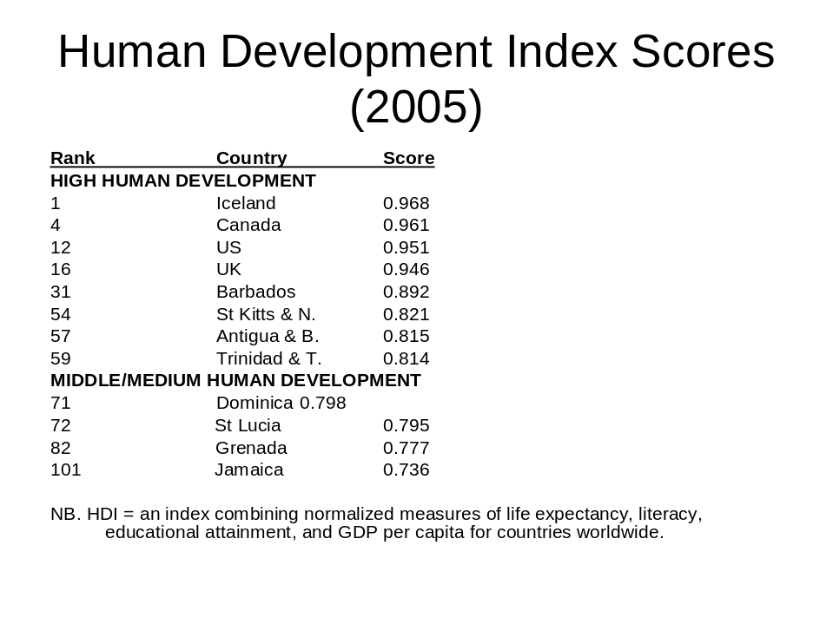

Part of the explanation for this is that these micro states have been functioning as providers or funders (in the case of voluntary education) or as recent regulators (in the case of social insurance) of essential public social services – and are expected to be doing so. In addition to residual systems of backstop, discretionary social assistance, they all operate self-funding social insurance systems to cover old age pensions, survivors benefits and sickness (though not usually unemployment); they all operate free basic systems of health care; and they all offer free primary and secondary systems of education albeit, as in Britain, not always under direct governmental control. And they all suffer from constant complaints about the quality and sufficiency of the services available which, in turn, has spurred the growth of supplementary private markets in health care as well as education for those who can afford it.

Thus, by the standards of a checklist compiled by the author some time ago (to distinguish between ‘true’ welfare states and other sorts of modern welfare regime), the islands of the ex-British West Indies score as true welfare states on every count except that of richness (Box 12). So how are they best to be described, for the time being ? As prototype welfare states (which seems diminishing); as homespun welfare states (which seems even more diminishing) – or perhaps as an own brand of ex-plantation welfare states, which could be the most diminishing of all.

Box 12

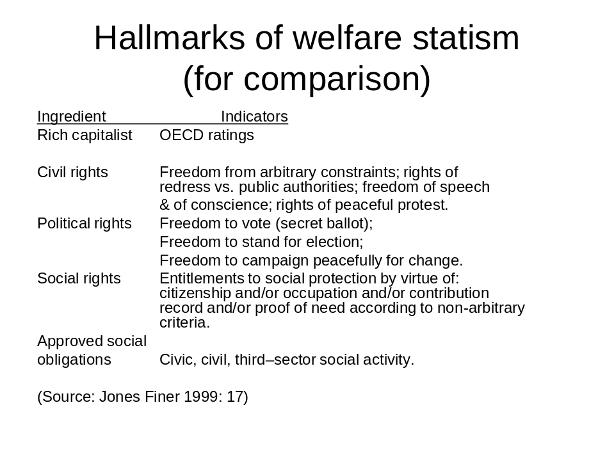
:
IN CONCLUSION

It is not easy to escape one’s past, either individually or collectively. At the same time, unfortunately, it is not easy to avoid having outsiders interpret alleged present predicaments all too simplistically in terms of what they see as past patterns of conditioning supposedly ‘uncorrected’ or incapable of change. The ideal solution from at least an academic point of view will be to end the West Indies’ virtual exclusion from international social policy debate and comparison (itself a past product of their being neither disastrous enough for ‘Development Studies’ nor successful enough for inclusion in ‘Comparative Social Policy’). Without comparison- and agreement over the criteria for comparability – there can be no measure of just how exceptional or otherwise these incipient welfare states (= another tentative definition !) are to be adjudged – let alone stimulated (if not provoked) into adjudging and accounting for themselves internationally.

The obvious comparisons so far have been with the welfare state (such as it is) in so-called ‘mother country’ Britain. However there are also questions worth raising in comparison with the beginnings of welfare statism in the Nordic countries. Baldwin (1990) famously located the beginnings of Scandinavian welfare universalism in the alliance of interests between key middle (ie farming) and working class groups which eventually contributed to the 1930s legislation for a ‘People’s Home’ in Sweden. Much has been remarked of the (superficially comparable) alliances of interest between the middle and working classes in the later developmental history of the British West Indies – but these only resulted in an even greater show of West Indies riots in the 1930s, being alliances of interest between the still dispossessed, politically as well as economically. To be sure, the riots resulted in eventual measures of political as well as social reform – though the latter not of course to the rioters’ prescription (had they ever been invited to prepare and present on the matter...).

Meanwhile, contemporary comparisons could be with the micro-ex-colonies of Hong Kong (now a Special Administrative Region of China) and Singapore: two of the so called productivist ‘little dragons’ of southeast Asia. The refugees flooding into these places after World War Two hadn’t expected anything of anyone – least of all from government; but then their predicament was that of peoples escaping, on their own account, away from forms of subjugation which were conceivably equivalent to slavery. Certainly there was no thought here of collective welfare being connected to anything other that a family’s willingness and ability to contribute to the fortunes of what was typically looked on as the Hong Kong PLC or as Singapore Inc.. How best are West Indian concepts of their respective states to be summed up, by way of comparison ?

This paper has tried to demonstrate, with reference to the outstandingly under-reported case of the former British West Indies, within a framework of comparative social policy development, just how much its past might still be governing its present, both at home and abroad.

This being a revision of the pope’s 1493 prescription which had situated the notional line just 100 leagues west of Cape Verde – a ruling which the Portuguese had objected to as unfair.
This being the century of the Protestant Reformation in northern Europe.
Privateers (English) and corsairs (French) sailed under the direct or indirect authority of their respective governments; whereas Buccaneers (a term derived from the practice of smoke-drying meat over a fire of green wood, which they had learnt from the Caribs) operated entirely on their own account.
In truth, it was defeated as much by British coastal weather as by English ships.
Prior to this “It is probable that English investors – chiefly London merchants – put more money into commerce and piracy in the Caribbean…than into any other mode of long distance, overseas business enterprise, even the East India Company.” (Dunn 2000: 10-11).
The Dutch for instance being more interested in commanding trade between the islands in the Caribbean and Europe.
The concept of ‘no peace beyond the line’ being first visualised by the French and Spanish negotiators of the Treaty of Cateau Cambresis in1559. (eg. Watts 1987:130 )
Details of the 1783 ‘Cedula of population. – see IT downloads.
Cuba, India, the Philippines etc.
The production of sugar from sugar beet being first sponsored by Napoleon from 1811 (to get round a British blockade of French sugar supplies from the West Indies). Beet sugar production subsequently increased throughout Europe, overtaking the tonnage of cane sugar production by 1880.
Though NB plantation negroes were reputed no more eager for changes in established practices than were plantation owners. Green: 1976:52.
Save to quite some extent in Barbados – see below.
A factor which tended to reduce the absoluteness of position & status according to racial classification. See above and also Watts: 355-6.
Note that the original French Revolutionary abolition of slavery had been replaced by its reinstatement in 1802 (destined to last up until 1848). Eg Drescher 1987:197.
Nor were they alone in this appreciation. The shift from slave labour to wage labour (or from chattel slavery to wage slavery, as nineteenth century radicals in England were wont to put it – eg Davis 1987:214) was seen as logical rather than momentous.
Sugar beet production – see Note 10 above.
Cf. Stanley’s contention in the House of Commons debates over the Emancipation Bill, 1833, that British abolition amounted to a ‘mighty experiment’. (Quoted from Green: 127)
Where over 90% of those in revolt were Barbadan born.
Latest estimates of the ethnic composition of today’s population of Trinidad put the percentage of East Indians at no less than 40.3%; as against 39.6% black; 18.4%; ‘mixed’; 0.6% white and 0.4% Chinese. Jamaica, by contrast, reckons itself 75% black; 13% Afro-European; just 3% East Indian and Afro-East Indian; and 5% white. All of the other islands describe their current population mix as at least 85 or more per cent black, with Dominica unusual simply for the proportion of its Mestizo (7%) and Amerindian (Carib-descended - 1.5%) inhabitants. [Internet sources= via ‘Island name: general data of the country’.]
NB. “Perhaps the most neglected index of popular welfare preference has been the private ownership of land, either as a means of livelihood or as a location for property. If kinship remains the natural focus of altruism, the commonest expression of this familial search for security is the acquisition of property and its transmission from one generation to the next.” Pinker 1979:229.
NB. Joseph Chamberlain’s intentionally landmark, turn of the century plan for Britain to start making the most of its great imperial estates, was tellingly focussed entirely on serving the interests of Britain.
The said council having been suspended in 1899.
NB The contribution of West Indian armed services volunteers to this.
Though NB the missionaries dearth of educational involvement in advance of the slaves’ emancipation – apart from the Quakers.
1870: The Forster Education Act in respect of elementary education for all.
Note that, unlike as was the case in British India (eg.Dimeo in Fischer-Tine & Mann 2004), there was never any demeaning uncertainty about West Indian physical prowess and potential in respect of cricket. Even ex-slaves on the plantations had long been perfecting their techniques of fast bowling – if only (for the time being) to supply local colonials with a searing (and no doubt to the bowlers satisfying) batting experience in advance of the so-called real cricket matches they were preparing for.
When mass Irish immigration into 1830s Britain had prompted its then government to set up Poor Law institutions in Ireland , in the expectation that this would cut down on the inflow of poor people from Ireland from then on. (eg Jones 1977: 57).
Cf The Roman Empire in relation to Britain.
Though NB the career of Eric Williams as a self-proclaimed exception to this rule. “The necessary social qualifications in Trinidad were colour, money and education, in that order of importance. My father lacked all three.” [Though his mother was of a lighter colour and had a French name “of which both she and my father were quite proud”.] (Quoted from Palmer 2006: 5-6)
Though read Gurley’s A Caribbean Tale (2006) for his account of a brazenly different success story.
The islands of the Leewards and Windards (which do not include Barbados and Trinidad) currently depend on tourism for more than half of their GNPs.
The lack of which is an abiding handicap for lush, tropical Dominica.

